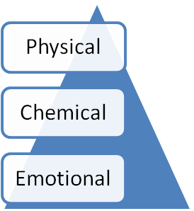
Stress Survey Your Name____________________________________ Today’s Date_________ Your e-mail for our free newsletter: ____________________________________ Please review each of these common stresses and circle when you experienced it in your life. Use P for Past and C for Current. If you expect or anticipate the possibility of experiencing this stress in the future, circle F for Future.

Physical Stress is what we do to our bodies: Explanation: 1.Forceps delivery P C F _________________________________________________ 2.Falls of any type P C F _________________________________________________ 3.Broken bones P C F _________________________________________________ 4.Strains or sprains P C F _________________________________________________ 5.Bad posture P C F _________________________________________________ 6.Poor sleeping habits P C F _________________________________________________ 7.Repetitive movements P C F _________________________________________________ 8.Sports injuries P C F _________________________________________________ 9.Heavy lifting and/or bending P C F _________________________________________________ 10.Overweight P C F _________________________________________________
Chemical Stress is what we do to our organs: Explanation: 1.Take prescription medication P C F _________________________________________________ 2.Take over-the-counter drugs P C F _________________________________________________ 3.Consume alcohol P C F _________________________________________________ 4.Consume caffeine P C F _________________________________________________ 5.Use tobacco products P C F _________________________________________________ 6.Eat fast foods P C F _________________________________________________ 7.Use artificial sweeteners P C F _________________________________________________ 8.Bad diet (white flour, white sugar) P C F _________________________________________________ 9.Exposed to environmental pollution P C F _________________________________________________ 10.Overweight P C F _________________________________________________
Emotional Stress is what we do to our minds: Explanation: 1.Divorce or parents or spouse P C F _________________________________________________ 2.Death of a loved one P C F _________________________________________________ 3.Serious illness (self or loved one) P C F _________________________________________________ 4.Financial concerns P C F _________________________________________________ 5.WORRY P C F _________________________________________________ 6.Work environment P C F _________________________________________________ 7.Relationships P C F _________________________________________________ 8.Anger by you or at you P C F _________________________________________________ 9.Feel “not worthy” P C F _________________________________________________ 10.Put things off to the last minute P C F _________________________________________________
Chronic stress forms the foundation of many health problems. Which of the 3 types of stress has had the greatest impact on your health and why?________________________________________________________________________

